Chapter 11, Solution 76.

The wattmeter reads the real power supplied by the current source. Consider the circuit below.
8 
j2 
-j3 
4 
120 V
330 A
+
−
V_{o}
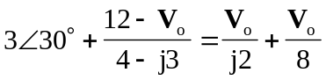
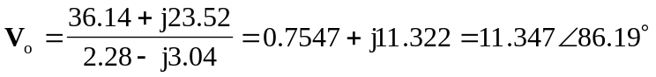

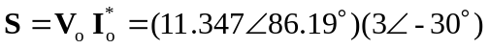
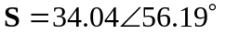VA

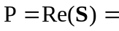18.942 W

